 | 1 | 2 | 3 | 4 | 5 | 6
1 | Dogs make better pets than cats.   | Your parents are your best teachers.  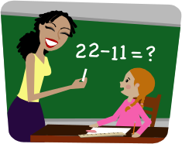 | You can learn more from real experiences than from books.   | Boys and girls should wear the same clothes.   | We all use our cars too much.   | We are becoming too dependent on computers.  
2 | All junk food should be banned.   | Happiness is more important than money.   | Computer games help you to develop useful skills.   | Books are better than films.   | Children should help at home with household tasks.   | It is cruel to keep animals in zoos.  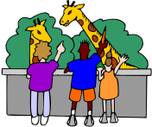
3 | Mobile phones should be banned in school.   | No one should travel on holiday by airplane. | War is always wrong.   | Every job should have the same salary.  | All school students should wear a school uniform.   | Rich countries should share their money with poorer ones. 
4 | Space exploration is a waste of money.   | Boys can run faster than girls.   | Britain should replace the royal family with a president.   | Footballers are overpaid.   | Children spend too much time on social media and are not developing social skills. | Dogs should always be kept on a lead when out.
5 | Watching TV before bedtime stops you sleeping.   | Children should not be allowed to bring sweets to school.   | Play times should be abolished.   | Children under 11 should be in bed by 9 o’clock.  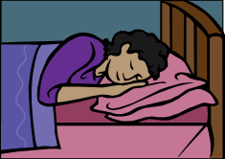 | Smoking should be treated as a drug and made illegal.  | We should always walk to school.  
6 | Under 16s should be banned from Face book.   | Homework is good for you.   | Your parents always know best.   | The use of animals to test drugs and other products should be banned.   | Girls work harder than boys. | Too much TV is bad for you .  

INSTRUCTIONS
Make a large version of the game and display at the front of the class (or make versions for each table and let small groups play).
Split the class or group into two teams.
Ask two children (one from each team) to come to front – decide who will be FOR and who will be AGAINST each argument. Give them each a dice. Ask one child to roll dice for the vertical and one for the horizontal axis in order to select the argument from chart/game board, which they will be arguing about. Each child has to give two reasons in favor or against the topic – if they take too long to think of something or give a bad reason the other team get a point! If they both come up with two good reasons for or against the argument, both teams get a point.
Encourage children to think of reasonable and valid arguments.

